# Lab 09a - Implement Web Apps

Made by Valeriy Manuilyk <3

## Task 1: Create and configure an Azure web app

1.Sign in to the ****Azure portal**** - https://portal.azure.com

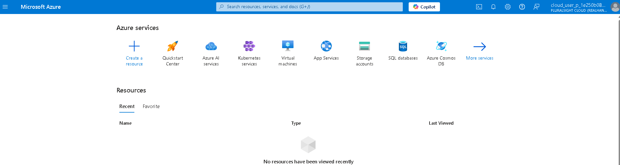

2.Search for and select App services.

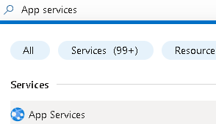

3.Select ****+ Create****, from drop-down menu, ****Web App****. Notice the other choices.

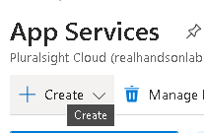

4.On the ****Basics**** tab of the ****Create Web App**** blade, specify the following settings (leave others with their default values):

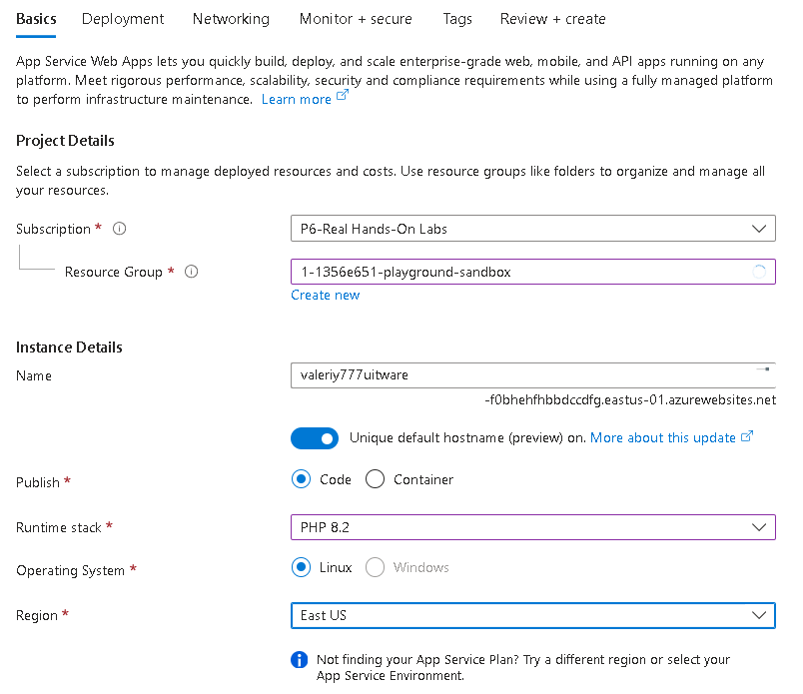

5.Click ****Review + create****, and then ****Create****.



6.After the deployment, select ****Go to resource****.

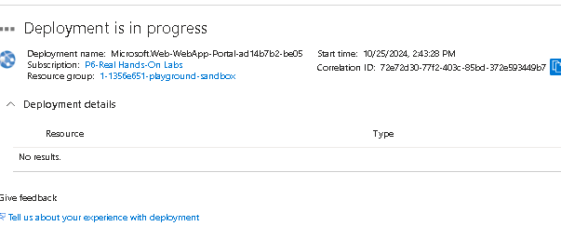

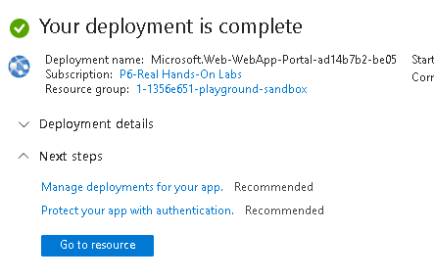

## Task 2: Create and configure a deployment slot

1.On the blade of the newly deployed Web App, click the ****Default domain**** link to display the default web page in a new browser tab.

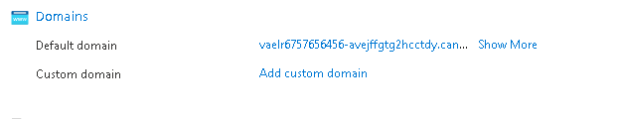

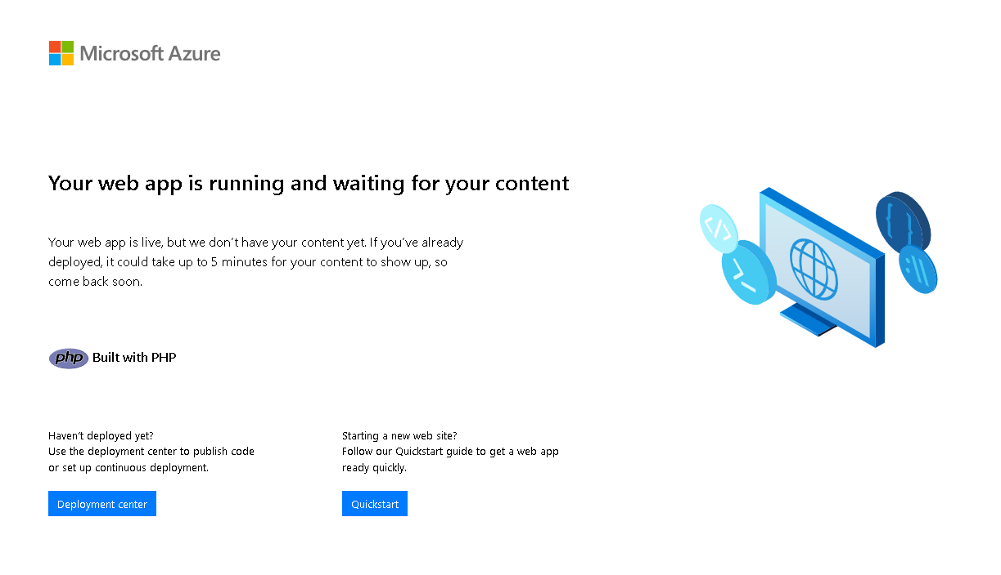

2.Close the new browser tab and, back in the Azure portal, in the ****Deployment**** section of the Web App blade, click ****Deployment slots****.

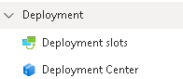

3.Click ****Add slot****, and add a new slot with the following settings:

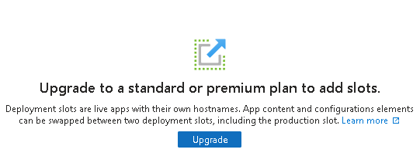

## Task 3: Configure Web App deployment settings

1.In the staging slot, select ****Deployment Center**** and then select ****Settings****

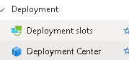.

2.In the ****Source**** drop-down list, select ****External Git****. Notice the other choices.

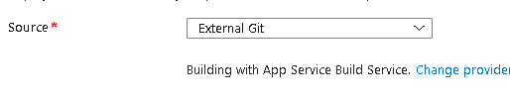

3.In the repository field, enter https://github.com/Azure-Samples/php-docs-hello-world



4.In the branch field, enter master.



5.Select ****Save****.



6.From the staging slot, select ****Overview****

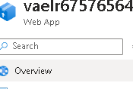

7.Select the ****Default domain**** link, and open the URL in a new tab.

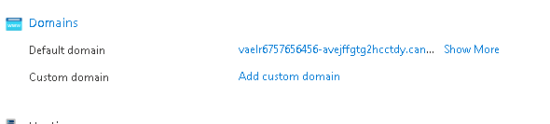

8.Verify that the staging slot displays ****Hello World****.



## Task 4: Swap deployment slots

1.Navigate back to the ****Deployment slots**** blade, and then select ****Swap****.

2.Review the default settings and click ****Start Swap****.

3.On the ****Overview**** blade of the Web App select the ****Default domain**** link to display the website home page.

4.Verify the production web page displays the ****Hello World!**** page.

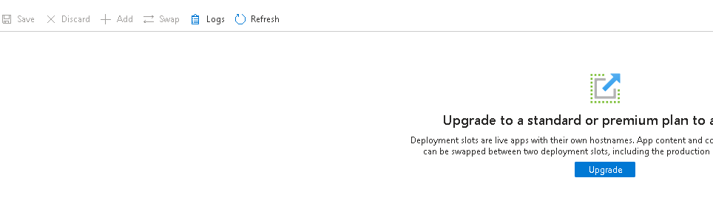

## Task 5: Configure and test autoscaling of the Azure Web App

1.In the ****Settings**** section, select ****Scale out (App Service plan)****.

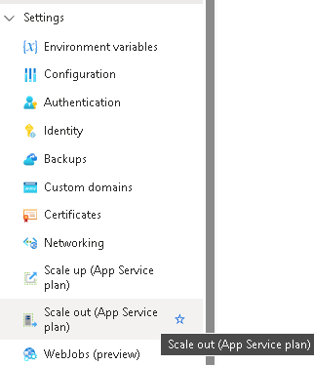

2.From the ****Scaling**** section, select ****Automatic****. Notice the ****Rules Based**** option. Rules based scaling can be configured for different app metrics.

3.In the ****Maximum burst**** field, select ****2****.

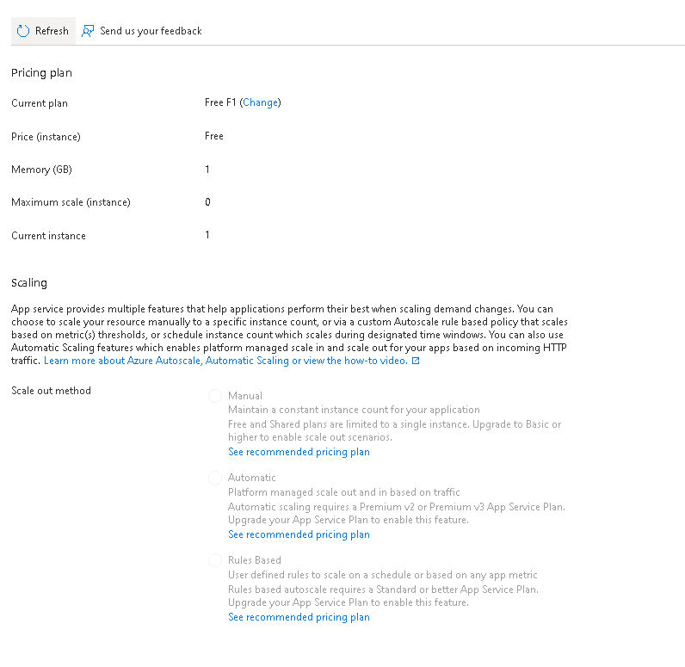

**Сonclusion:**

Azure App Services lets you quickly build, deploy, and scale web apps.

App Service includes support for many developer environments including ASP.NET, Java, PHP, and Python.

Deployment slots allow you to create separate environments for deploying and testing your web app.

You can manually or automatically scale a web app to handle additional demand.

A wide variety of diagnostics and testing tools are available.